Cloud automation

Public cloud is more service

AAD—managing Identity –authentication and authorization.

Ingress controller for load balancer—accessing application

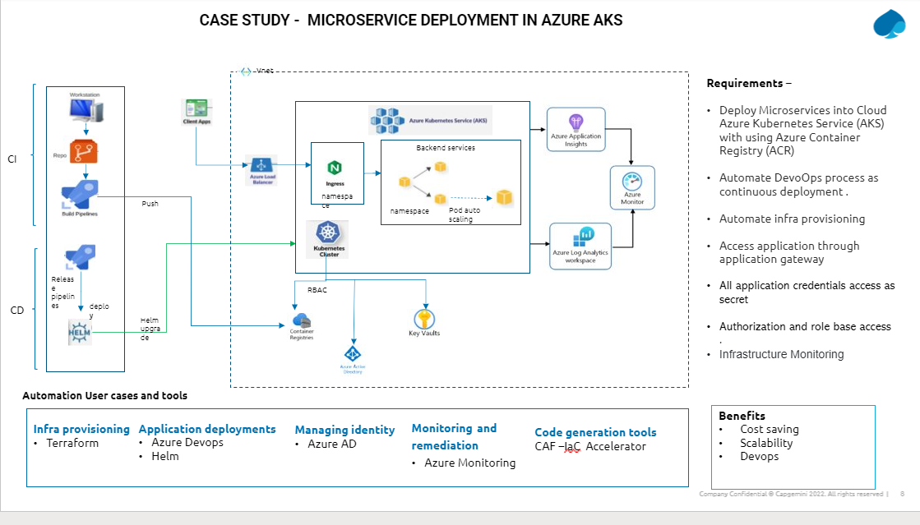

Helm

Manisto files\

